GET ALL POSTS
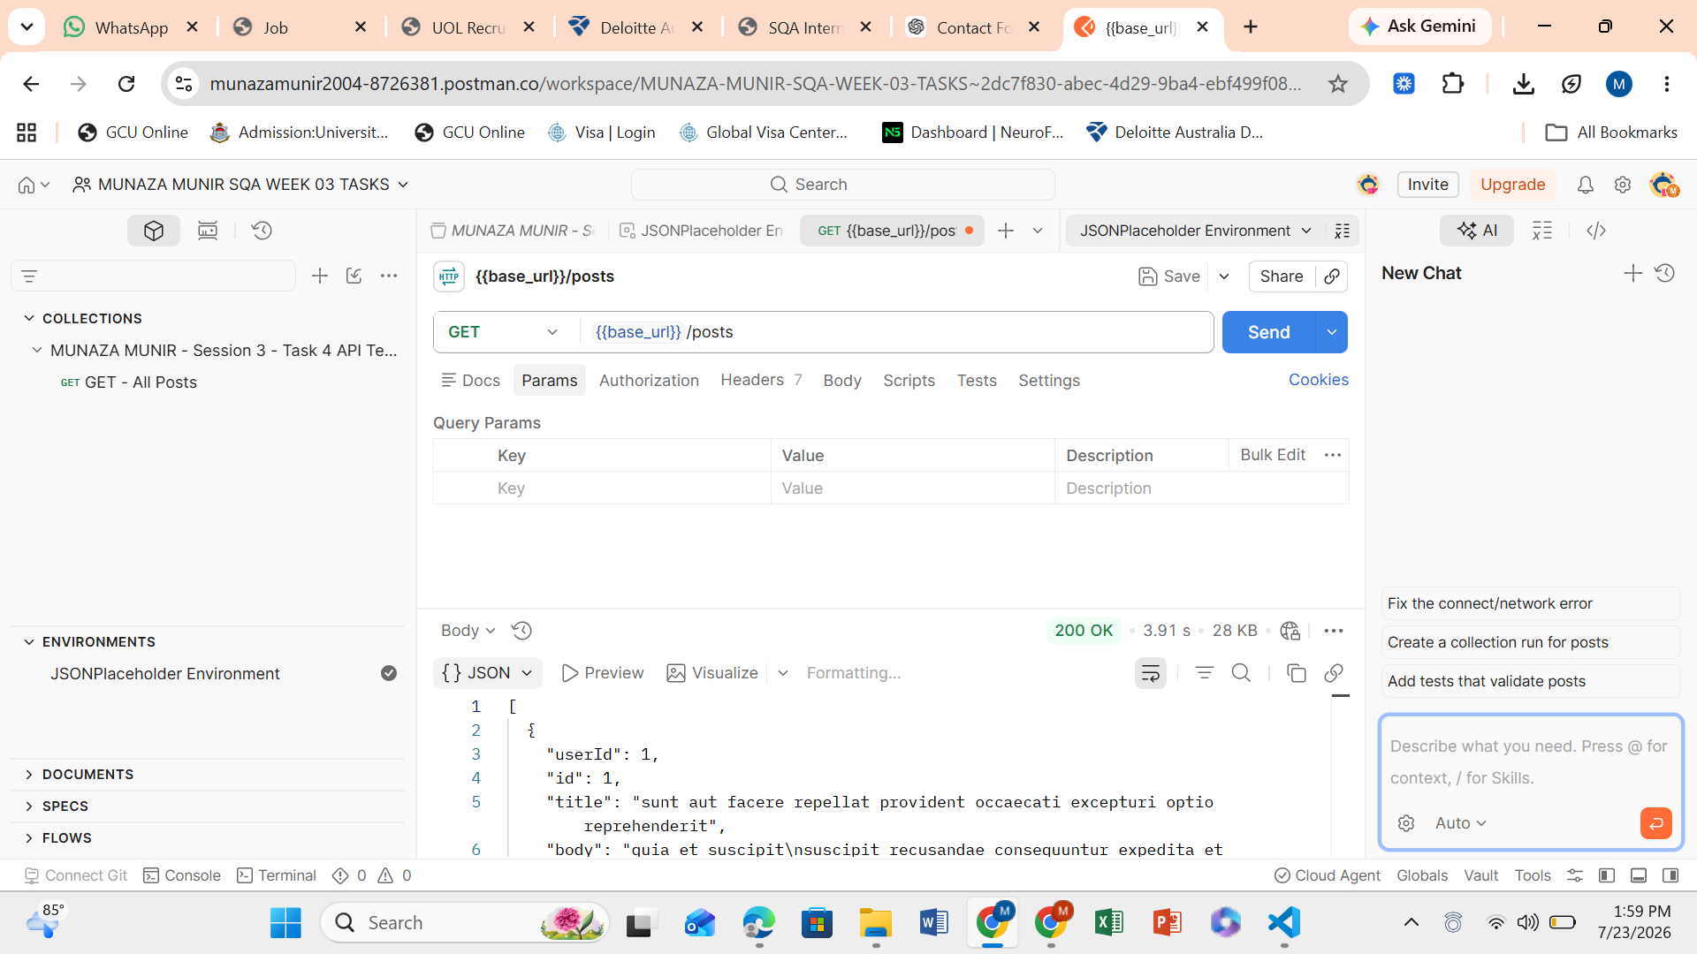
GET REQUEST WORKING AND COMPLETED 200 OK GET – ALL POSTS DONE
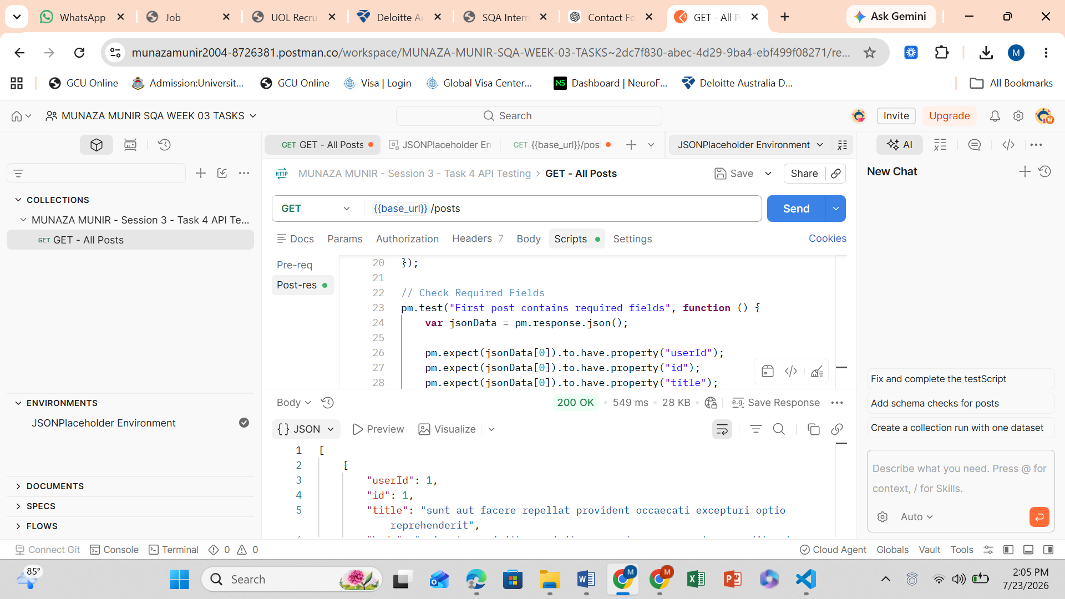

Request 1 ✅ GET - All Posts (Completed)
Method: GET
URL:
{{base_url}}/posts
Status: 200 OK ✅

GET – SINGLE POST DONE
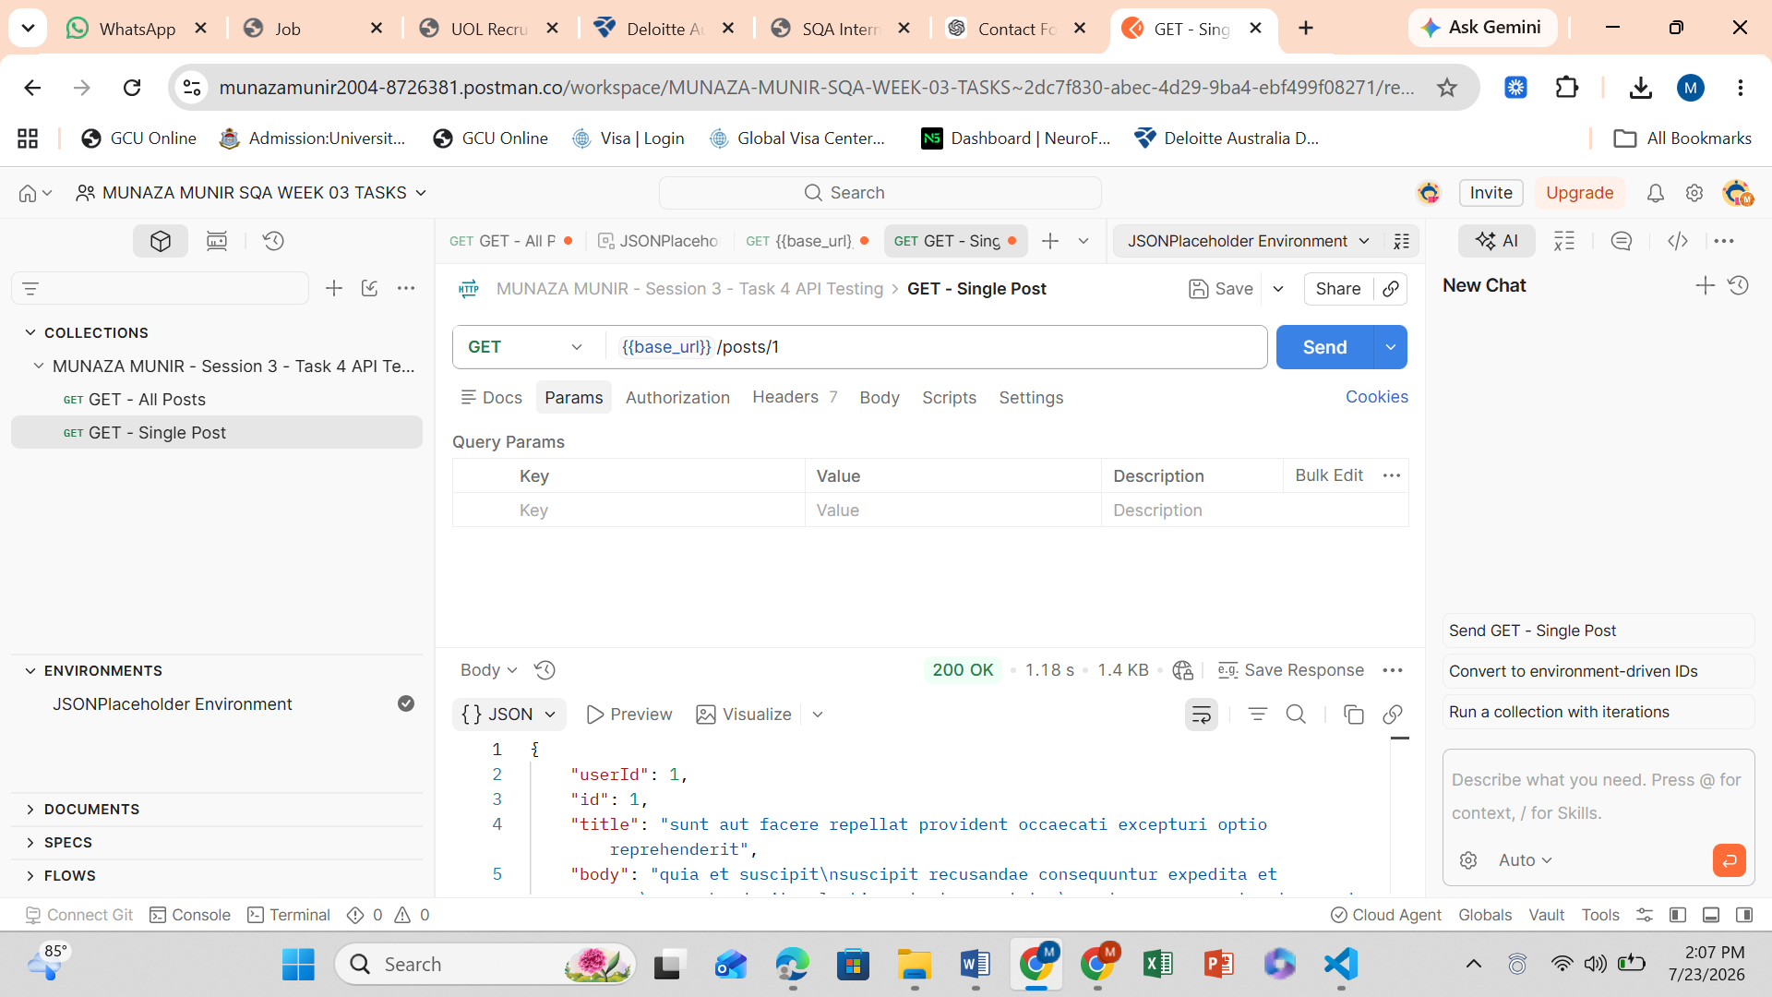

GET – INVALID POST NEGATIVE TEST
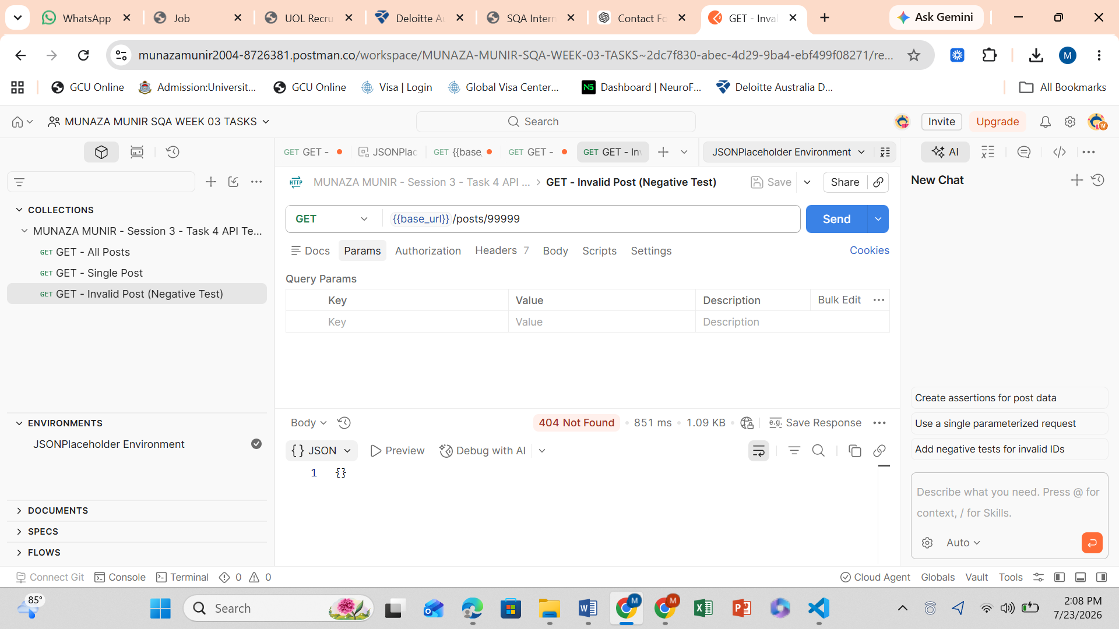
POST – CREATE POST
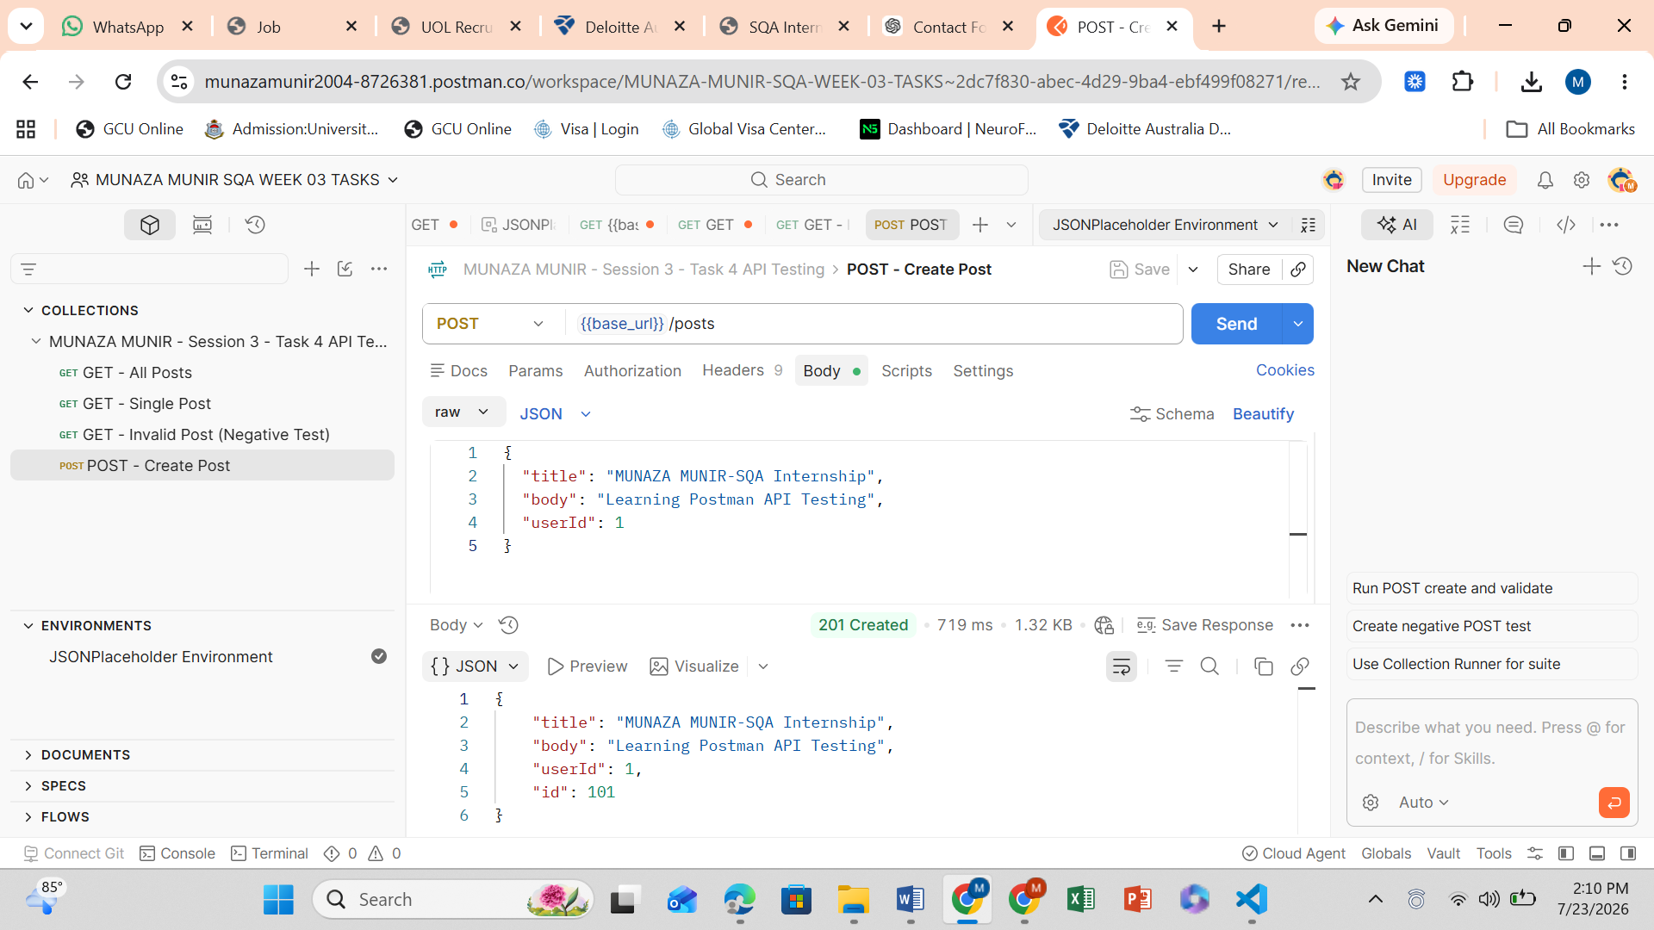

POST – INVALID DATA NEGATIVE
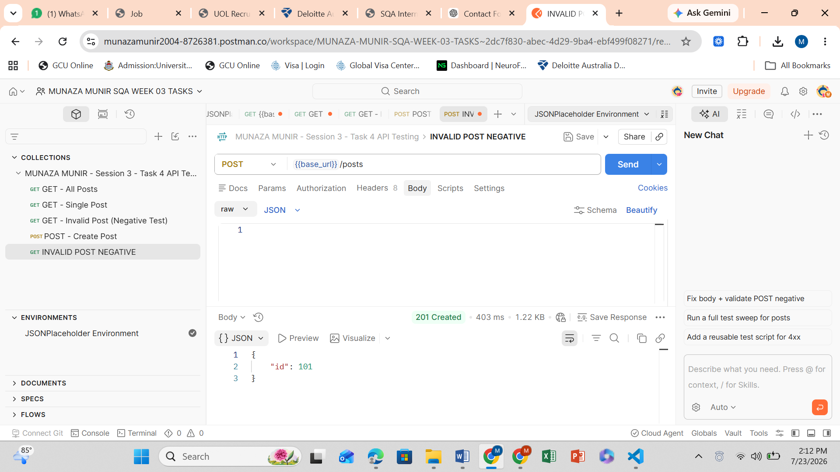

PUT UPDATE POST
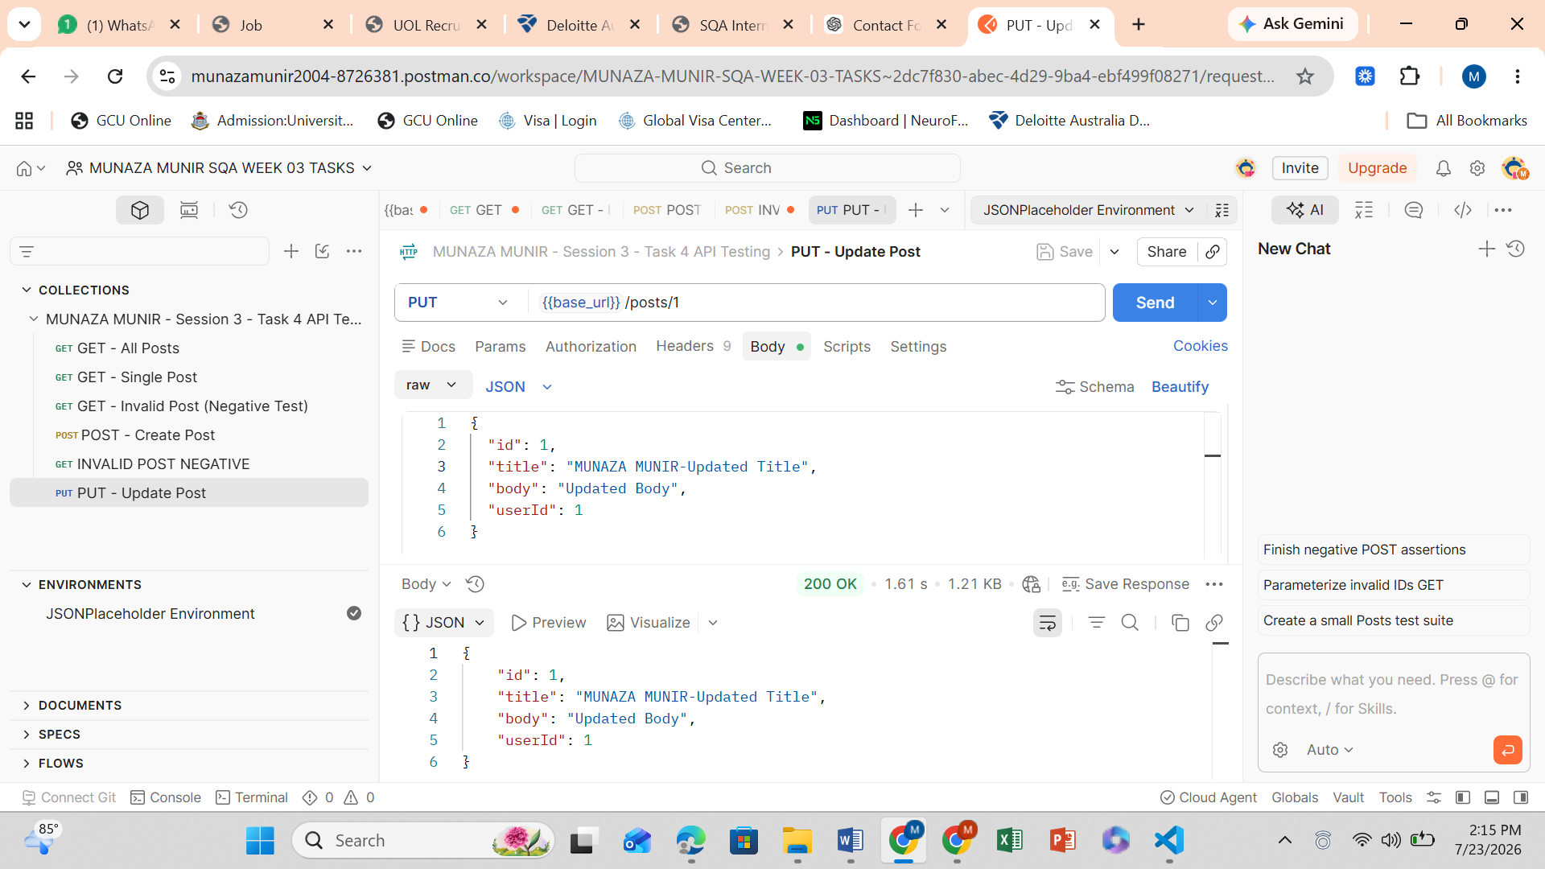

PATCH – UPDATE TITLE
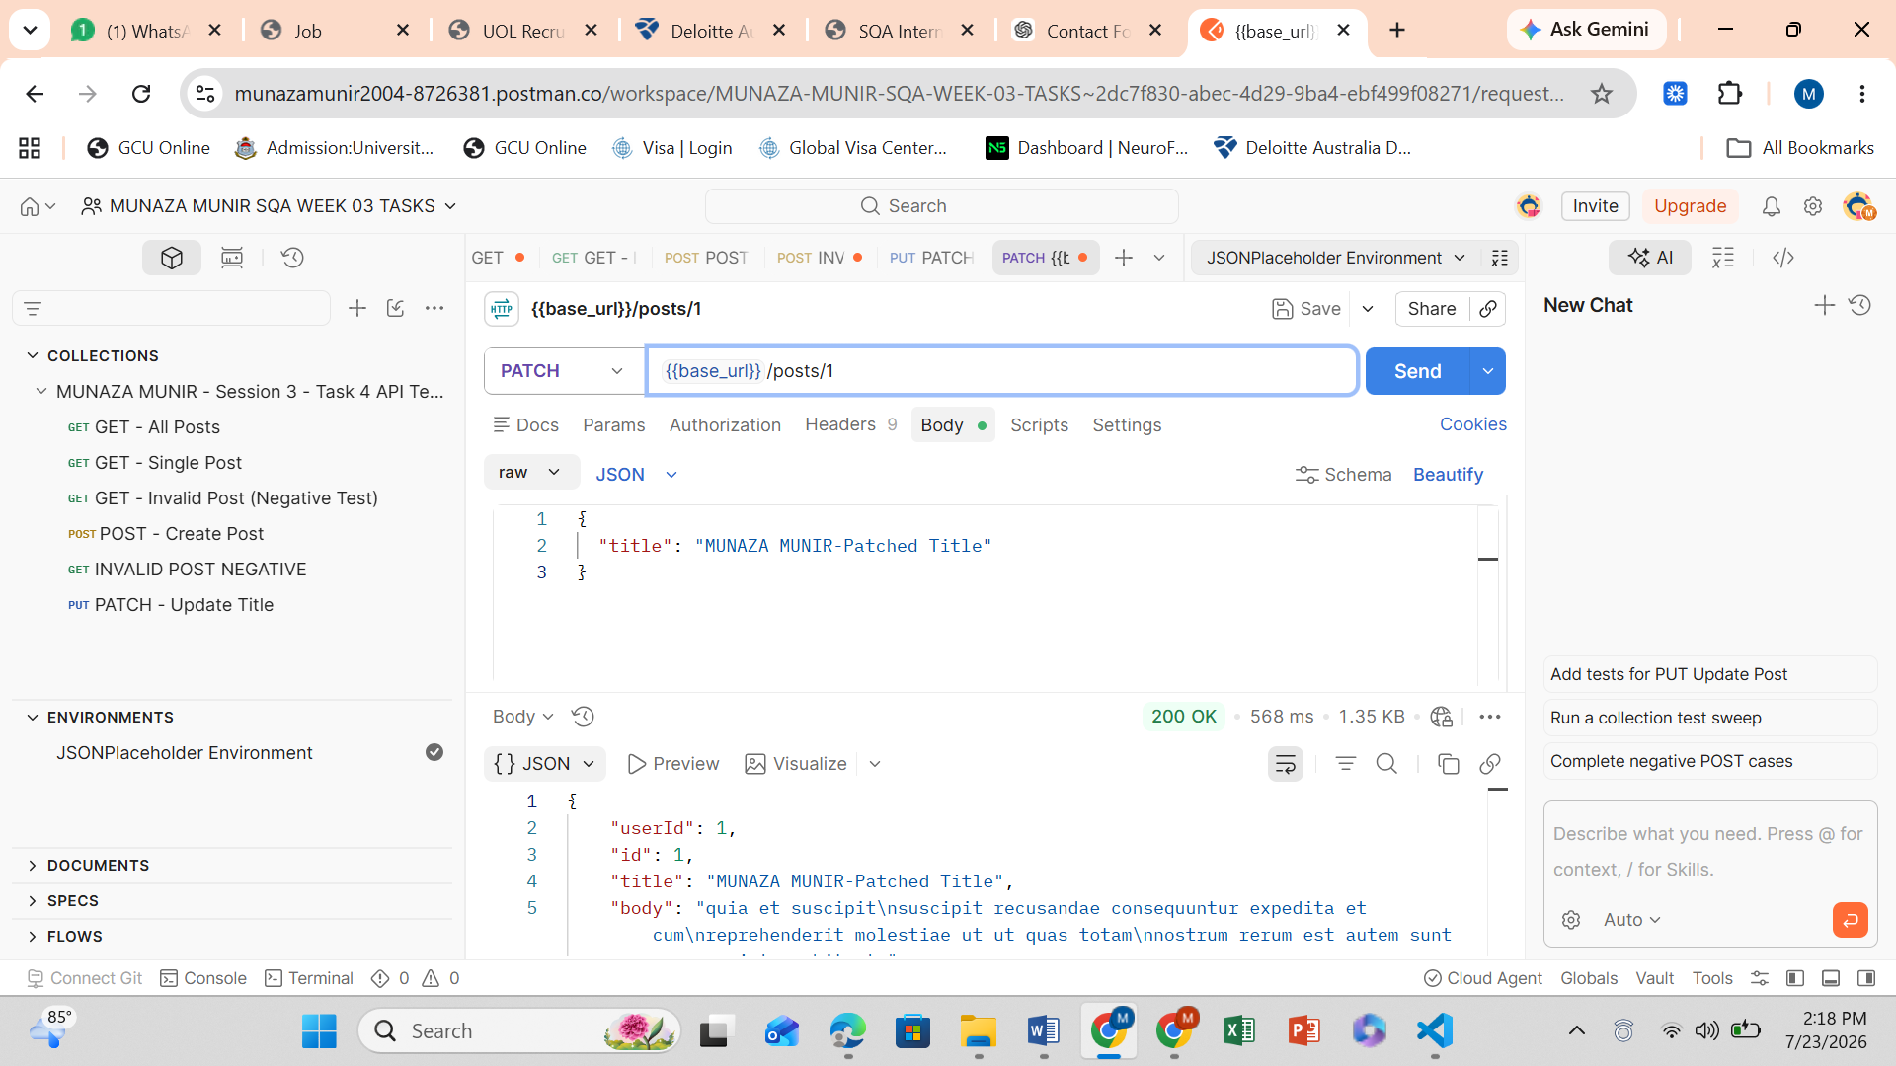

DELETE – DELETE POST
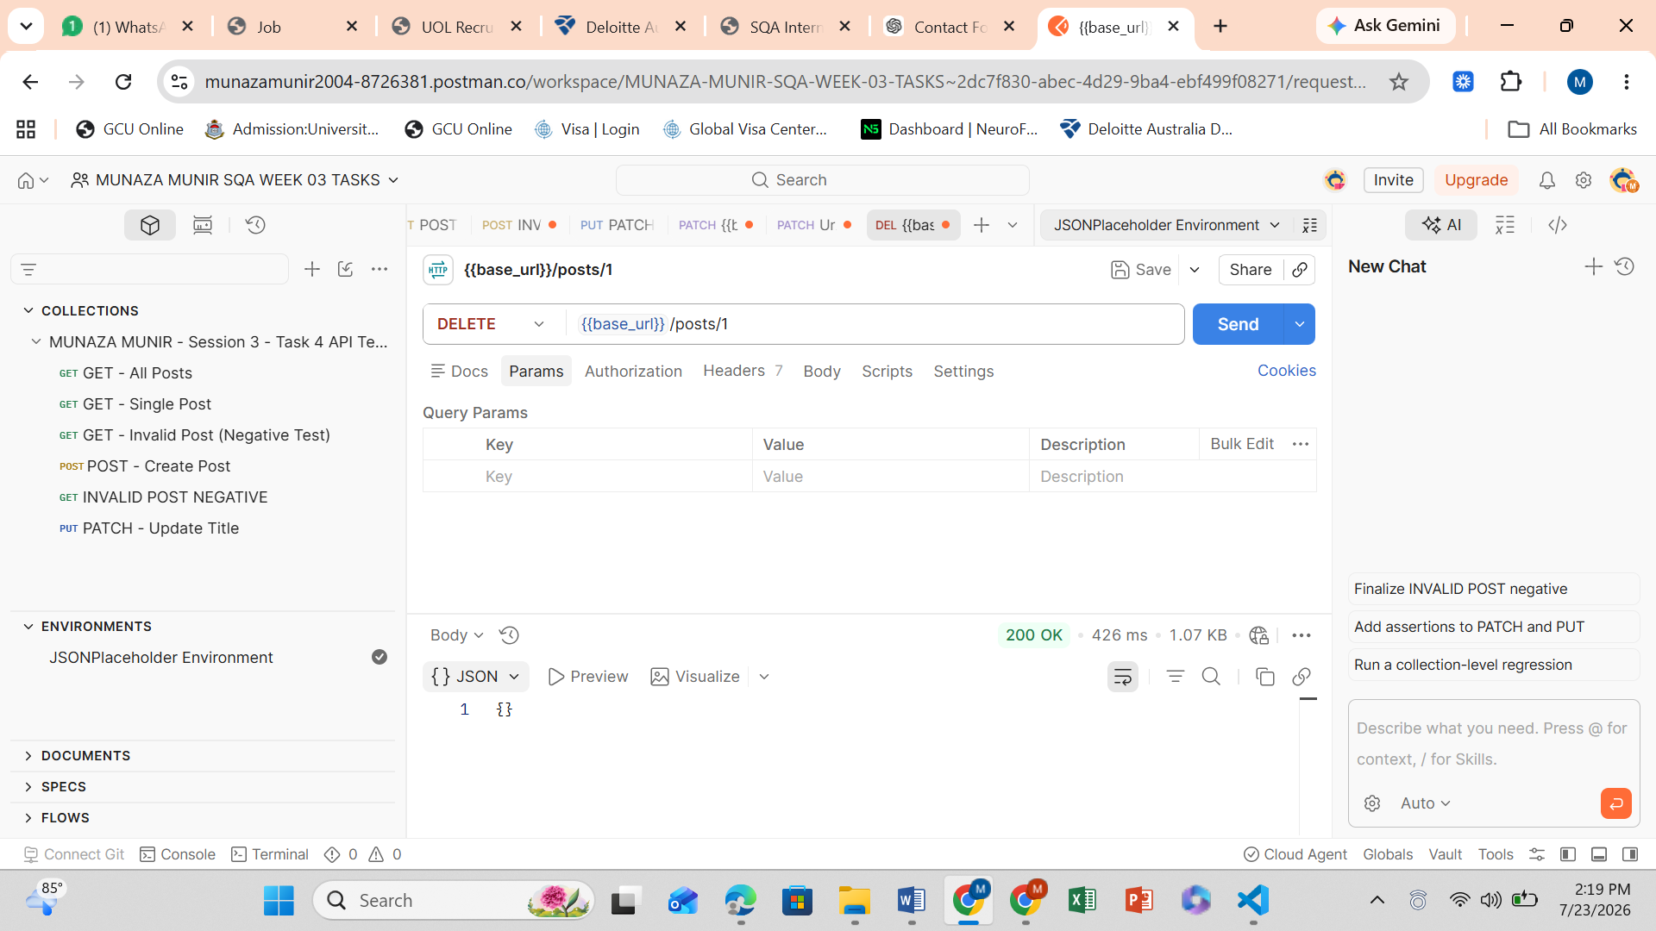
ALL 8 REQUESTS COMPLETED.
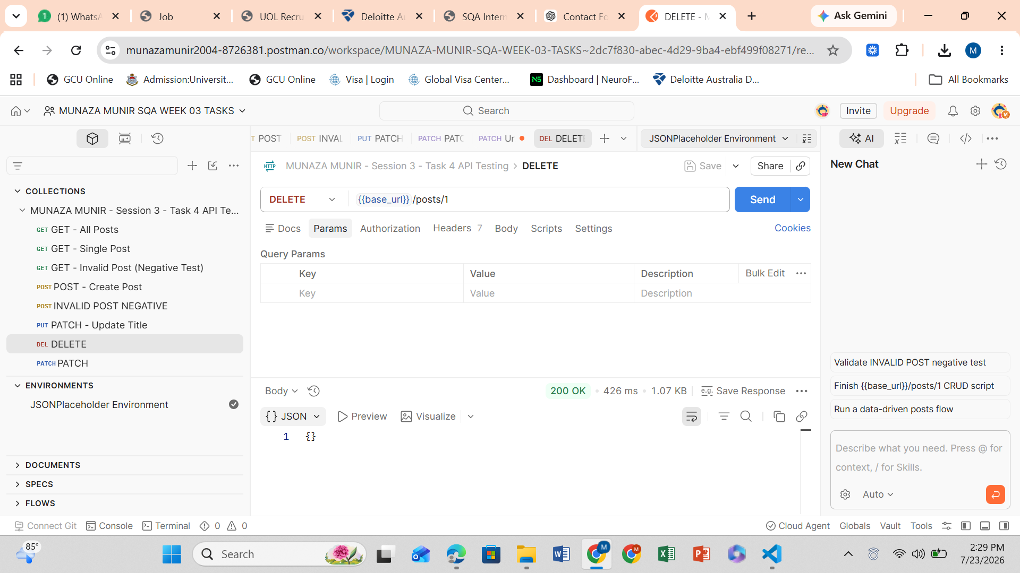

FULL COLLECTION RUN SUCCESSFULLY
